Directions to our office (HandS Korea):
Take the subway line 9 to Deungchon Station (Express Subway should not stop at the Deungchon Station), and exit #7. Walk out of the exit and go straight for about 2-3 minutes until you see a GS25 gas station ahead and to your right. Take a right turn just before the gas station, and walk about 50 yards. Our building is to your right, and is across the street from Adonis Bar or Paggy Pie. Go into the building, up to the 3rd floor.

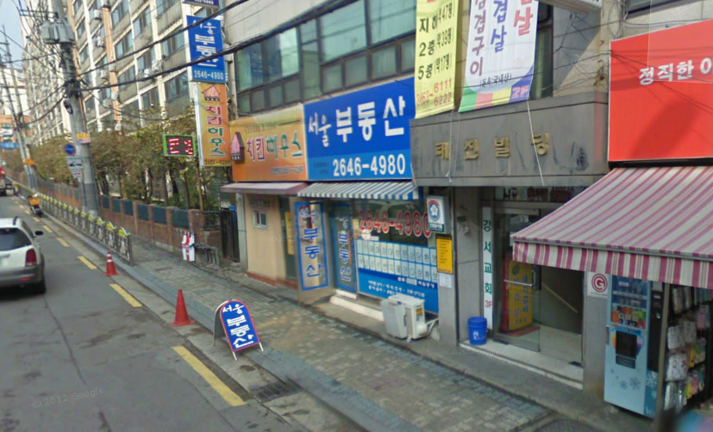

It’s just past the building with the red awning. (in front of Paggy Pie)

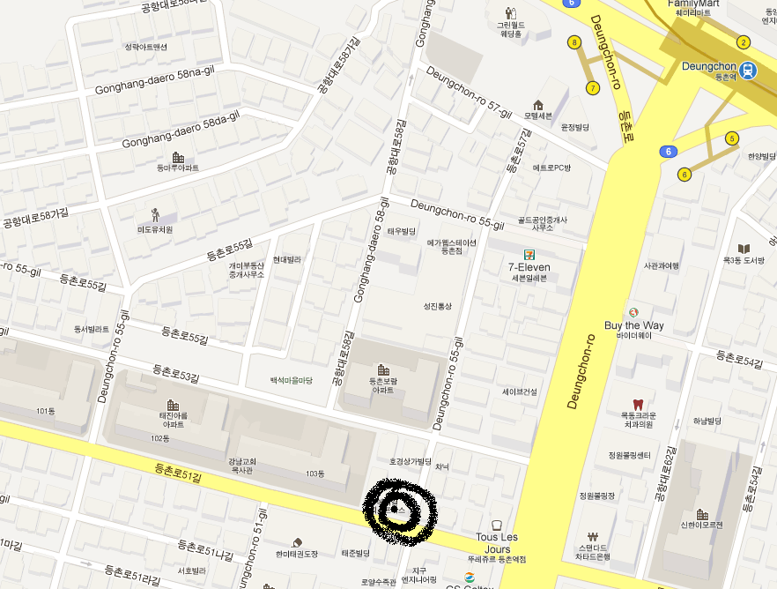

Here is the google map.

